Fingerprint and iris voting system

PROJECT SUMMARY

The AI & IoT Based Smart Electronic Voting Machine (EVM) is a secure and intelligent voting system developed to eliminate electoral fraud, duplicate voting, and manual identity verification delays. In traditional voting systems, officials verify voter identity using physical ID cards and voter lists. This process is time-consuming and can lead to human errors, proxy voting, and unauthorized access.
To overcome these limitations, the proposed system uses Artificial Intelligence (AI) and Internet of Things (IoT) technologies to automate voter authentication and vote registration. The system is designed around two main hardware units:
- ESP32-CAM Module – Captures the voter’s face and streams real-time images over a private local Wi-Fi network.
- ESP32 DevKit V1 – Acts as the core Electronic Voting Machine (EVM) controller and manages all hardware peripherals.
The captured facial images are processed by a Python-based backend server running on a computer. Using OpenCV and the face_recognition library, the system extracts unique facial features and compares them with a pre-registered voter database. Each face is converted into a 128-dimensional mathematical encoding, which enables accurate and fast face matching.
When a registered voter is successfully identified, the Python server sends a secure HTTP request to the ESP32 DevKit over the local Wi-Fi network. Upon receiving this authorization signal, the ESP32 unlocks the voting interface.
The voter can then cast a vote using push buttons, while receiving step-by-step guidance through a 16x2 I2C LCD display. An active buzzer and status LEDs provide immediate audio and visual feedback after successful vote submission.
If an unregistered face is detected, or if authentication fails, the system remains locked and an alert is generated. This prevents unauthorized voting and ensures that each registered voter can vote only once.
The entire system operates within a private local network, reducing latency and eliminating dependence on internet connectivity. This architecture improves speed, reliability, and data security while maintaining a transparent and tamper-resistant voting environment.
Overall, the proposed system demonstrates how AI and IoT can be combined to create a modern, secure, and automated electronic voting solution suitable for educational prototypes and future real-world deployment.
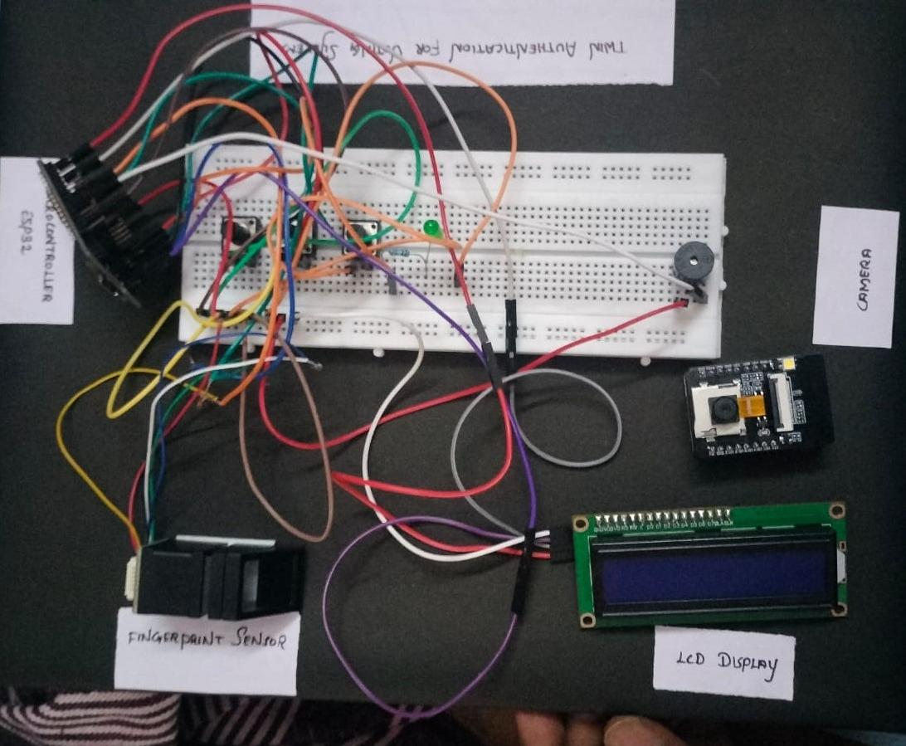

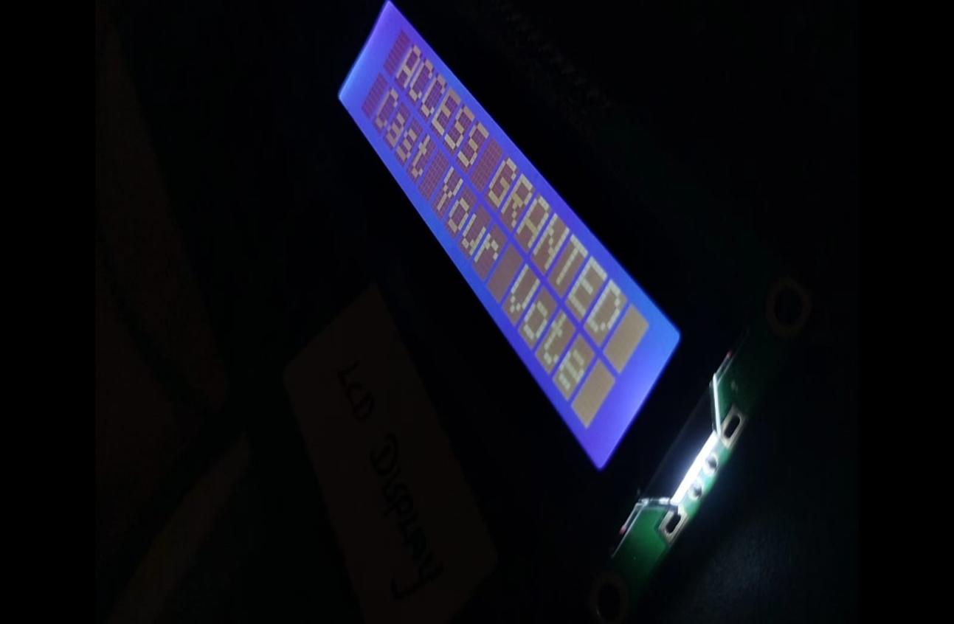

TECHNICAL STACK (SOFTWARE & HARDWARE CONFIGURATION)

1. Python 3.10 – Main Backend Processing Engine
Python serves as the central processing environment of the entire voting system. It is responsible for receiving live video frames from the ESP32-CAM, performing facial recognition, validating voter identities, communicating with the ESP32 controller, and managing the overall workflow. Python was selected because of its simplicity, extensive library support, and excellent compatibility with Artificial Intelligence and Computer Vision applications.

2. OpenCV (cv2) – Real-Time Image Processing Framework
OpenCV is used to capture and process the live video stream transmitted by the ESP32-CAM module. It handles tasks such as frame acquisition, image resizing, face detection, and display of real-time monitoring windows. This library provides high-performance image processing functions that enable efficient and accurate visual analysis.

3. face_recognition Library – AI-Based Facial Authentication
The face_recognition library is the core Artificial Intelligence component used for biometric verification. It converts each detected human face into a unique 128-dimensional numerical encoding and compares it with pre-stored voter encodings. If a match is found, the voter is authenticated and allowed to access the voting interface.

4. ESP32-CAM Module – Wireless Vision Node
The ESP32-CAM module is equipped with an OV2640 camera sensor and built-in Wi-Fi capabilities. It captures the voter’s facial image and streams the video to the Python server over a private local network. This module acts as the image acquisition unit of the system and eliminates the need for expensive external cameras.

5. ESP32 DevKit V1 – Electronic Voting Machine Controller
The ESP32 DevKit V1 functions as the main hardware controller of the Electronic Voting Machine. It receives authorization commands from the Python server through HTTP requests and controls all connected peripherals, including the LCD display, voting buttons, buzzer, and status LEDs. It also records and processes the final vote.

6. 16x2 LCD Display with I2C Module – User Information Interface
The LCD display provides real-time instructions and status messages to the voter. Typical messages include “Scan Your Face,” “Access Granted,” “Select Candidate,” and “Vote Successfully Cast.” The I2C interface reduces wiring complexity by using only two communication pins.

7. Push Buttons – Candidate Selection Interface
Tactile push buttons are used as voting inputs. Each button corresponds to a candidate or political party. Once authentication is completed, the voter presses the desired button to cast a vote securely.

8. Active Buzzer – Audio Feedback System
The active buzzer generates audible alerts during different stages of the voting process. It beeps when authentication is successful, when a vote is recorded, or when unauthorized access is detected.

9. LED Indicators – Visual Status Notification
Two LEDs are used to indicate system status:
- Green LED indicates successful authentication and vote registration.
- Red LED indicates authentication failure or unauthorized access.

10. HTTP Protocol over Local Wi-Fi – Communication Bridge
The system uses HTTP requests over a private local Wi-Fi network to establish communication between the Python server and the ESP32 controller. This method ensures fast, reliable, and low-latency data exchange without requiring internet connectivity.

11. SQLite Database – Local Vote and Voter Storage
SQLite is used to store registered voter information, face encodings, voting status, and vote counts. It is lightweight, serverless, and ideal for offline embedded applications.

12. Arduino IDE 2.x – Firmware Development Environment
Arduino IDE is used to write, compile, and upload firmware to the ESP32-CAM and ESP32 DevKit boards. It provides built-in support for ESP32 development and simplifies hardware programming.

13. Visual Studio Code – Backend Development Platform
Visual Studio Code is used to develop and debug Python scripts. It offers intelligent code completion, integrated terminal support, and extension-based enhancements for efficient software development.

14. Windows 10/11 Operating System – Host Environment
The Python backend server runs on a Windows-based computer, which hosts all required libraries and manages communication with the IoT hardware modules.

15. Local Wi-Fi Network – Private Communication Infrastructure
A dedicated local Wi-Fi network connects the ESP32-CAM, ESP32 DevKit, and Python server. Since all devices communicate within the same private network, the system remains fully operational without internet access, enhancing security and reliability

